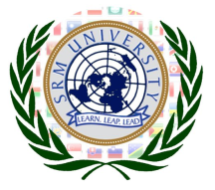
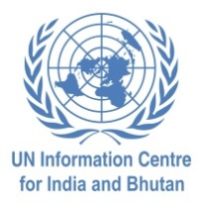
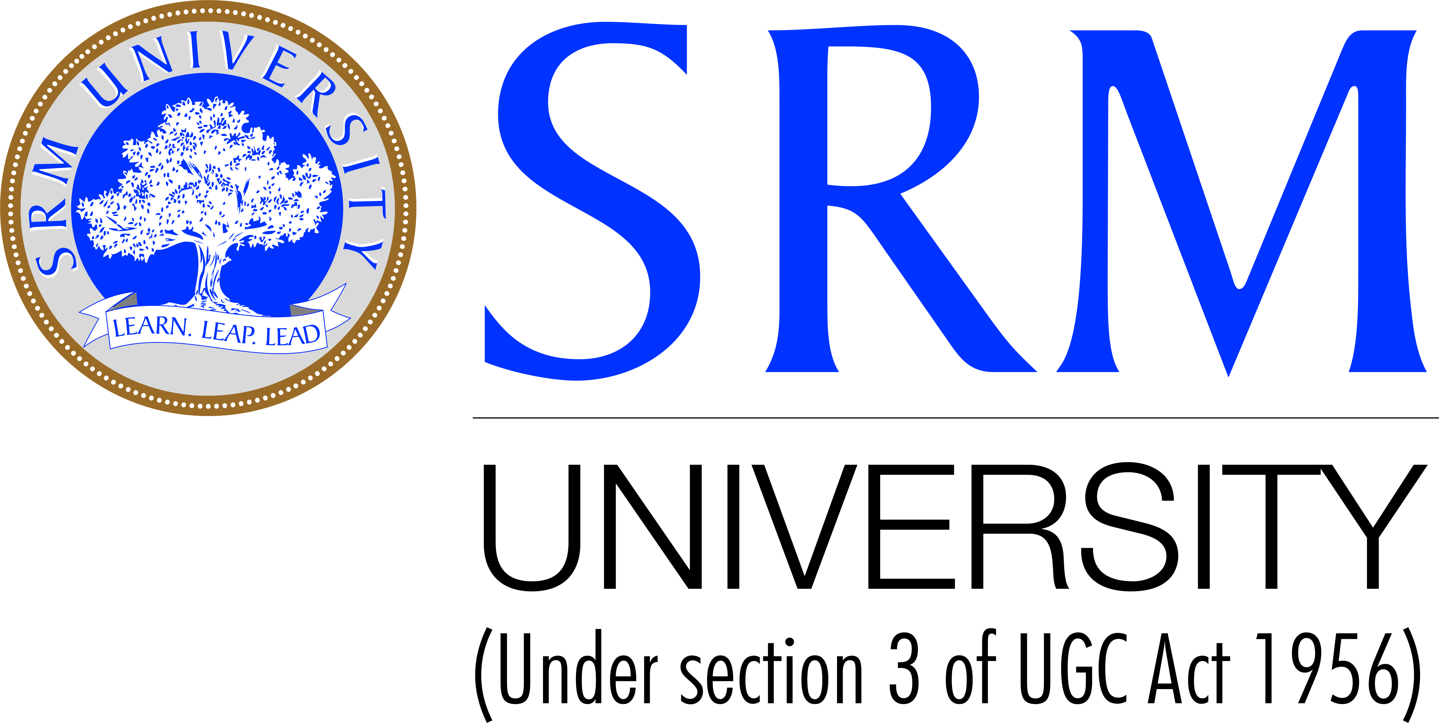

To,
The Institute Head,
Sub: Invite for SRMMUN 2013 being held at SRM University, Chennai
It is hereby affirmed that <name>has been selected as delegate of <country>in <committee>for SRMMUN 2013 to be held at SRM University, Kattankulathur Campus, and Chennai from 22nd to 24th February, 2013.
SRMMUN is a unique event, bringing together delegates from Colleges all over India, creating a vibrant and dynamic platform for students to engage in debate on major issues that are in focus around the world today. It is aimed at educating the participants about current events of International importance and giving them a perspective on International relations, diplomacy and the agenda of the United Nations.
Today SRMMUN is immensely popular and held in high regard by MUN patrons across the globe for ensuring a highly intellectual level of debate, and at the same time, a reputation for attracting the most fun-loving delegates.
This year, SRMMUN 2013 will be bigger than ever with seven different councils which will provide over 500 delegates a platform to indulge in an intellectual discussion on issues of global relevance and share their views with likeminded delegates from across the nation.
With such massive participation SRMMUN is indisputably among the largest, most successful and widely recognized MUN’s in the country.
We would be deeply grateful for your cooperation for providing leave/OD for the applicant to attend the conference.
Thank you.
Yours sincerely,
Team SRMMUN 2013
SRM University, Chennai

