TIMELINE OF EVENTS

- The United States Invasion of Panama, code-named Operation Just Cause, occurred during the administration of U.S. President George H. W. Bush and resulted in the removal of de facto Panamanian leader, general, and dictator Manuel Noriega. The president-elect Guillermo Endara was sworn into office and the Panamanian Defence Force dissolved.
- On December 15, 1989, the Panamanian legislature declared Noriega president and that the US and Panama were in a state of war. Following the shooting of a U.S. Marine, President George Bush ordered Operation Just Cause, an invasion consisting of over 25,000 soldiers. The mission was controversial due to the resulting loss of hundreds of Panamanian lives and the subsequent damage to Panama City and El Chorillo.
- On December 20, 1989, over 27,000 U.S. troops invaded the small Central American country of Panama. The U.S. military was faced by the Panama Defence Force (PDF) and its 3,000 soldiers. After the PDF crumbled, fighting by irregular Panamanian militia lasted a few days.
- The United States had numerous military bases and substantial deployments throughout the Canal area to protect the Panama Canal which belonged to the United States of America.
- On September 7, 1977, Jimmy Carter, President of the United States and the de facto leader of Panama, General Omar Torrijos, signed a set of agreements called the Torrijos–Carter Treaties.
- The treaties detailed the process of how the Panama Canal was to be handed over to Panama by the year 2000. Although the canal was destined for Panamanian administration, the military bases remained and one condition of the transfer was that the canal would remain open for American shipping.
- At the same time the U.S. had past relations with General Noriega who had served as an intelligence asset and informant since 1967, including when Bush was head of the CIA (1976–77).
- Ronald Reagan, President of the United States, started negotiations with General Noriega in 1988, requesting him to peacefully step down after the Panamanian leader was publicly exposed in the Iran-Contra Scandal.
- Members of the Pentagon began pushing for a U.S. invasion in 1988, but Reagan refused. In March of the same year, an attempted coup against the government of Panama was resisted by Noriega's forces. As relations between United States and Panama continued to deteriorate, Noriega started to shift his Cold War allegiance towards the Soviet bloc by soliciting and receiving military aid from Cuba, Libya and Nicaragua.
- The Panamanian national elections were held in May 1989, during which an alliance of parties opposed to the military dictatorship of Noriega counted results from the country's election precincts before they were sent to the district centres. Their tally showed their candidate, Guillermo Endara, defeating Carlos Duque, candidate of a pro-Noriega coalition, by a huge margin.
- Next day Noriega declared the election null and maintained power by force.
- In its defence the Noriega's government said that it had won the presidential election free and fair and that irregularities had been on the part of U.S.-backed candidates from opposition parties.
- Tensions escalated when Bush called on Noriega to honour the will of the Panamanian people which was followed by the United States reinforcing its Canal Zone deployment, and increasing the intensity of training operations with the intention of putting pressure on Noriega.
- A second coup attempt by members of the Panamanian Defence Forces (PDF) in October 1989 was foiled by Noriega followed by the declaration from President Bush that the U.S. would not negotiate with a known drug trafficker.
- The Panamanian general assembly, on December 15, passed a resolution declaring that the actions of the United States had caused a state of war to exist between Panama and the United States.
- The catalyst that greatly intensified the crisis was shooting of American soldiers when four U.S. military personnel were stopped outside PDF headquarters in the El Chorrillo neighbourhood of Panama City, resulting in the death of one officer. According to U.S. military, a U.S. naval officer and his wife witnessed the incident and were subsequently detained by Panamanian Defense Force soldiers. While in police custody, they were assaulted by the PDF.
- The next day, President Bush ordered the execution of the Panama invasion plan; the military set H-Hour as 0100 on December 20.

Policy statement on the ongoing conflict between the United States of America and the Republic of Panama by the United States of America
The conflict that has emerged in between between the United States of America and the Republic of Panama is being dubbed as an invasion of the latter by the former. However, nothing could be farther from the truth.
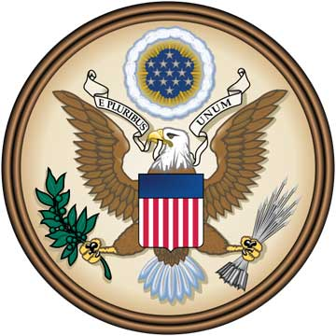
The relationship between both our nations before this grave turn of events was based on mutual trust, friendship and economical benefit. America was just as shocked as the world when Noriega declared himself as General of the armed forces in 1983. Violations and disregards to the Treaty of Neutrality were already reported to our government. After condemning the actions of all those responsible, diplomatic efforts began between the nations again, all of which involved the cutoff of power to Manuel Noriega. These concerns and efforts were conveniently shunned. Attempts at sanctions and moves to restrict by USA as well as other concerned organizations were nullified by the increasingly powerful men and women of influence under Noriega. The rigging of elections, the blatant violations of human rights, the state of jeopardy into which the people of Panama were put because of Noriega’s tyranny, not to mention the danger that the tens of thousands of Americans in Panama were in had all become reasons for the international community to act. In such a scenario, it was necessary to ensure the safety of the Panama Canal, a reason that pushed us to increase the garrison around the area. Everything changed, however, on 15th December 1989.
The government of Panama headed by Noriega declared absolute war on the United States. This was escalated by the attack of the PDF on a group of US soldiers. Our government is revolted by this act. The failure of diplomacy has caused us to act on behalf of the world. The Americans living there have to now be either brought back home safely or be ensured of persistent safety of the place they are living in. The declaration of war has also crushed all grounds on which the Treaty of Neutrality was built and it is essential that now we do what is necessary to bring the Canal back to its state of normalcy. Noriega has directly taken action against a nation responsible for the safety of the world, thereby putting world peace in the balance. This action has to be reversed. Human beings no matter what their nationality do not have to be victims of oppressive dictatorship. They certainly do not have to bow down to a man who is allowing his own nation to implode from the core. All these and the need to maintain peace as a vigilant superpower have made it necessary for us to act.
In light of the current scenario, we the Americans sincerely hope that our actions aren’t interpreted as an invasion or a belligerent action but merely a retaliatory measure and a response to acts of war by the other nation in this conflict. Diplomacy played her hand and failed. International sanctions played theirs and fell. Noriega’s actions have already made him a war criminal and a murderer under international law. Peace can only be achieved by bringing him to justice. All those responsible for these atrocities must be handed over immediately. This will be the beginning of a better and safer Panama.

Policy statement on the ongoing conflict between the United States of America and the Republic of Panama by the Republic of Panama

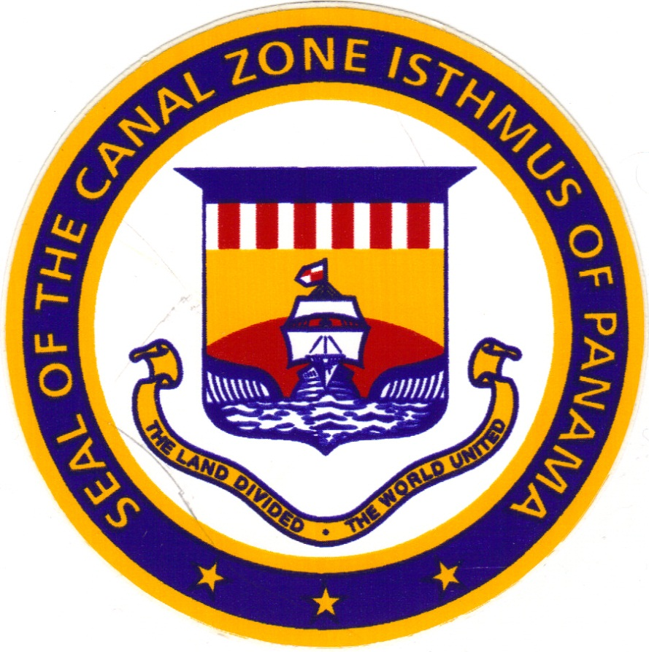
It is a well-known fact that Panama is in a state of war that has been forced upon it by another nation, since 20th December, 1989. The simple fact is that the United States of America are the aggressors and in this case, were the first to take offensive action against another Sovereign State. As is their wont, they claim to be the party taking steps in the right direction and taking action for the good of all. A week has passed and the casualties are piling up. The United States of America seems to be using the United Nations as its tool. As has been brought to the notice of the delegate of Panama, a draft resolution which was introduced in the United Nations Security Council was voted against by the United States of America although there was a majority support for it. It is imperative to note that they are permanent members, thus their negative vote is counted as a veto. This can only mean that the United States of America is going against popular demand for it to back out from the internal matters of other nations. Something they seem to loathe doing, in this instance. Make no mistake, this is an internal affair and the United States of America is an uninvited interference. Similar to the case in Vietnam, the Panamanian Defense Forces will keep them at bay till the international community can understand the atrocities that they are inflicting on the good people of Panama. We urge the international community to come to a consensus on asking them to pull out of our nation. Yes, this letter is not an appeal to ask for any kind of military help but simply a document that is requesting the world to take steps to put right the wrong that is being furthered by the United States of America. If the ongoing conflict cannot be resolved in this manner and the United States of America continues to carry out belligerent attacks on Panama’s sovereign soil, then the Panamanian Defense Forces will not back down. The PDF will hold and carry out attacks, just as it is being forced to do over the past seven days.
“To safeguard the lives of Americans, to defend democracy in Panama, to combat drug trafficking and to protect the integrity of the Panama Canal treaty.” – George H. W. Bush
These were the reasons stated by the President of the United States of America to justify the invasion of Panama by them. Around that time, approximately 27,000 U.S troops have breached Panama sovereign territory. The invasion involves the use of massive armaments, advanced military equipment, tactical air strikes, tanks and even paratroopers. Furthermore, to add to the gross violations of sovereign rights, the United States of America has sworn in a puppet President, Guillermo Endara, to establish a U.S friendly regime in Panama without the consent of the people of Panama. The delegate of Panama fails to understand what kind of democracy is being practiced or defended here. On the topic of combating drug trafficking, the United States of America knows this as well as most that Panama has always been instrumental in lending support to any kind of measures taken to prevent the inflow of narcotics into the United States of America from South America. Therefore, this reason should be considered as a smoke-screen as to the true interests of the U.S in carrying out an invasion of Panama. To safeguard the lives of Americans is another reason being stated. There has been no documented or known attack on any civilian American life in Panama or the Canal Zone that has been done without some kind of provocation. Thus, this is more of speculation than anything. Finally, we have arrived at the real reason behind the invasion of Panama: The Panama Canal Treaty. The Torrijos-Carter Treaties abrogated the Hay-Bunau Varilla Treaty of 1903. The Panama Canal was to be returned to its rightful owners. Why would the PDF have any reason to jeopardize the successful transition of this control, particularly after both nations had ratified the Treaties? Is it that the United States of America had a sudden change of heart as to the transferring of control of the Panama Canal? Or, is it that the U.S wanted a puppet regime to rule Panama and cause the control of the Canal to still be indirectly under their control? The answers to these questions are quite obvious and plainly visible.
Finally, regarding the Panamanian people that the United States of America is claiming to be the savior of, the story told is incomplete. In this invasion, heavy U.S firepower has been turned on civilian communities. The poor working class neighborhood of El Chorillo has been burnt to the ground. It is estimated that more than 2,000 people have already been killed. Many of them were dumped into mass graves. Witnesses report that U.S. troops used flame-throwers on the dead, the bodies shriveling up as they burned. So, as the war rages on in our beloved homeland of Panama, this forum must be used as a means to resolve this conflict. Have no misconceptions, it will be resolved, one way or the other.

This record contains the original text as delivered in English. Interpretations would be available in the Official Records of the General Assembly.

Corrections/Objections/Reconsiderations should be submitted to the original text only. They should be sent under the signature of a member of the delegation concerned, within one week, to the Secretariat.

